**Research Question:**

Participants were recruited to play Family Feud with research assistants. They were told to compete for the high score by guessing the most common words related to a category word. See below for example … they would not see the words until they got them correct:

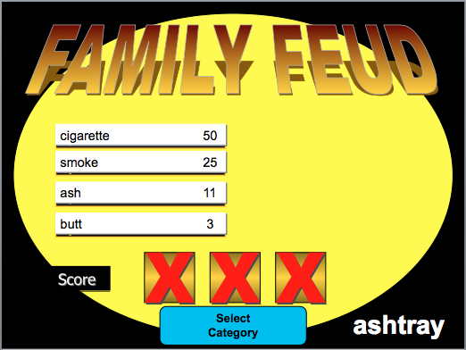

Include the appropriate output into this document while answering the questions. You can also upload your excel file for data screening, which will help us figure out what happened if your answers are incorrect. In the assignment, you will delete people (the whole row) if they should be excluded.

**Between Subjects IV(s):**

* Group: Different types of Family Feud were given to participants
  + Without numbers: traditional Family Feud without the scores they would receive for getting it right
  + With numbers: Family Feud modified to show participants the scores they would receive if they got them right
* Helpers:
  + Singles: participants worked alone
  + Doubles: participants worked in pairs

**Repeated Measures IV(s):**

* Forward: Strength of relationship between words that you would normally be guessing in family feud (i.e. ashtray to cigarette)
  + Levels: High, Medium, Low (first part of variables H_, M_, L_)
* Backwards: strength of reverse relationship (i.e. cigarette to ashtray)
  + Levels: High, Medium, Low (last part of variables H, M, L)

**Between Subjects DV:**

* Total Score: participants final score in the family feud game, higher scores indicate they did better (0-640).

**Repeated Measures DV:**

* Percent correct: the number of each combination of forward and backwards relationships they guessed correctly (0-1).

**Research Questions:**

* Repeated measures only: Is there an interaction between the forward and backward strength in the probability of getting the words right? Basically, does the backward strength help participants get more of the medium-low relationship forward words?

**Data Screening:** No data screening on this assignment because it was completed on the mixed ANOVA assignment.

**Power:**

1. Calculate the number of participants you would need for the research question, assuming a large effect size.
   1. Include a screen shot or summary of the numbers you typed into G*Power, so we can give you partial credit if you get a different sample size than us.

**ANOVA:**

1. Run the ANOVA for each research question and include the output.
2. Make sure Levene’s and Mauchly’s output is included when necessary.

**Post hocs:**

1. **Be sure to analyze the interaction even if it is not significant.**
2. Calculate the means, standard deviations, and group sizes for your conditions.
   1. Include the tapply ouput.
3. Post hocs:
   1. What type of post hoc *test* did you run?
   2. What type of post hoc *correction* did you run?
   3. Include the t-test output.
4. Effect size:
   1. Calculate the effect size for your pairwise comparisons.
   2. Include the effect size output or MOTE screen shot.
5. Fill in the table below with the information from the above calculations (like the one from the notes):

|  |  |  |  |  |
| --- | --- | --- | --- | --- |
| Mean 1 | Mean 2 | P-value | Explain? | Effect size |
|  |  |  |  |  |
|  |  |  |  |  |
|  |  |  |  |  |

**Graph:**

1. Include a graph of the means and confidence interval for your ANOVA. Be sure to check the following:
2. X-axis label
3. Y-axis label
4. X-axis group labels
5. Error bars
6. Cleaned up graph (no gray backgrounds)

**Write up:**

1. Write up an analysis of what you find in this data, including all the information you answered above. Use the example in the notes for a guide. This write up should include the following for credit:
2. Result section style (APA and AMA):
3. Double space
4. Times New Roman 12 point
5. Two decimals
6. Centered, bolded Results
7. Short description of the study/variables.
8. Data screening summary:
9. Accuracy – did you have problems? What did you do to fix it?
10. Missing data - did you have problems? What did you do to fix it?
11. Outliers - did you have problems? What did you do to fix it?
12. Assumptions:
    * 1. Additivity
      2. Normality
      3. Linearity
      4. Homogeneity
      5. Levene’s/Mauchly’s
13. ANOVA
14. Overall F statistics
15. Post hoc tests / corrections and results
16. Effect size for all tests
17. Graph with reference to the figure in the text.